**MEDIA CONTACTS :**

**MEDIA CONTACTS:**

**Adaora Onyebeke**

[adaora@philharmonicsociety.org](mailto:adaora@philharmonicsociety.org)

**Marie-Songco Torres**

[marie@philharmonicsociety.org](mailto:marie@philharmonicsociety.org)

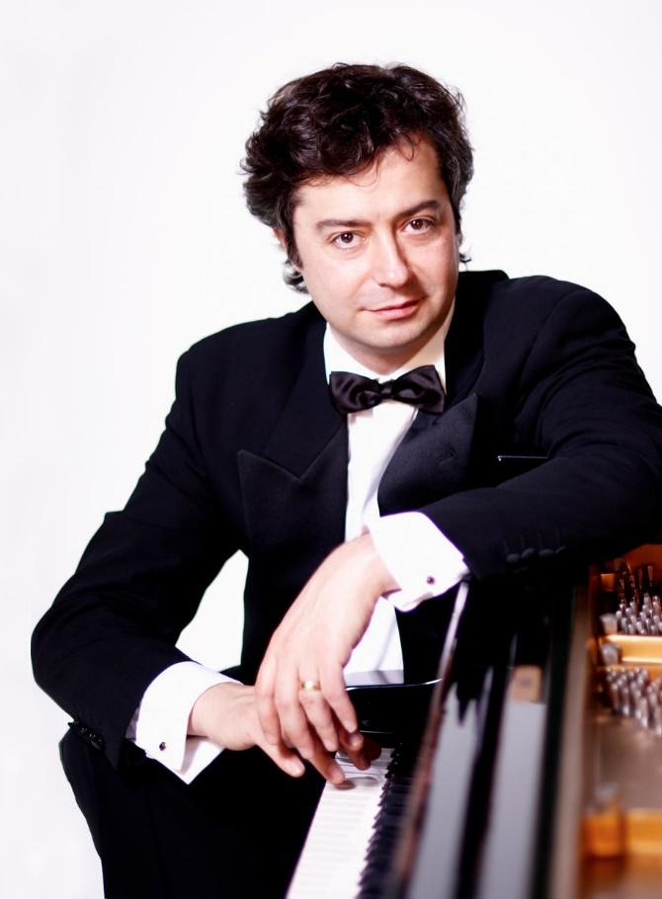**ACCLAIMED MODIGLIANI QUARTET JOINS WORLD-RENOWNED PIANIST FABIO BIDINI TO PERFORM RAVEL, BRAHMS & TURINA**

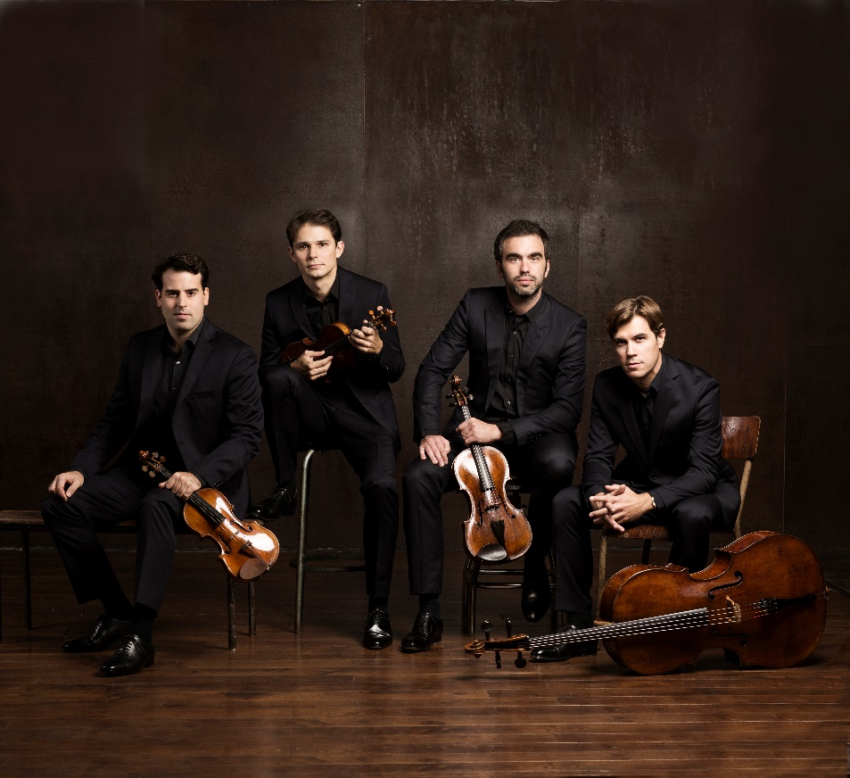

Photo: Jérome-Bonnet

Photo: Courtesy of the artist

**(IRVINE, CA, SEPTEMBER 5, 2024)**—Described as “one of today’s best quartets in the world” by the *Süddeutsche Zeitung*, the Paris-based Modigliani Quartet joins world-renowned Italian pianist Fabio Bidini on Friday, October 25, 2024, at 8pm at the Irvine Barclay Theatre. This chamber concert, presented by the Philharmonic Society of Orange County, showcases a captivating repertoire of popular works from Turina’s *La Oración del torero (The Bullfighter’s Prayer),* toRavel’s Quartet in F major, and Brahms’ Piano Quintet in F minor.

Founded in 2003, the **Modigliani Quartet**, consisting of violinists Amaury Coeytaux and Loïc Rio, violist Laurent Marfaing, and cellist François Kieffer, is recognized as one of today’s most sought-after quartets and is featured regularly in prominent international series and on the world’s most prestigious stages. In 2017, the quartet became the first string quartet to ever perform at the prestigious Elbphilharmonie in Hamburg. In addition to annual tours in the United States and Asia, the quartet’s numerous European tours have brought them to Wigmore Hall, Paris Philharmonie, Théâtre des Champs Elysées, Berlin Philharmonie, Vienna Konzerthaus, and Saint-Petersburg Philharmonia.

In 2020 the quartet became Artistic Director of the string quartet festival “Vibre! Quatuors à Bordeaux” as well as the renowned “The Bordeaux International String Quartet Competition.” The quartet is also the Founder and Artistic Director of the Saint-Paul-de-Vence Festival.

Modigliani Quartet has recorded for the Mirare label since 2008 and has released 13 award-winning CDs. In January 2024, the quartet’s latest album featuring quartets by Grieg and Smetana was published and received enthusiastically by the international press. The recording was featured in the bestseller list at the “Preis der deutschen Schallplattenkritik.” In the 2024-2025 season, the Modigliani Quartet will tackle one of the greatest challenges in the life of a string quartet: recording all 16 of Beethoven’s string quartets.

Italian pianist **Fabio Bidini** is one of his generation’s top-flight pianists. His appearances have included performances with the London Symphony Orchestra at The Barbican, Philharmonia Orchestra of London at Royal Festival Hall, San Francisco Symphony, New World Symphony, Dallas Symphony, St. Louis Symphony, Budapest Festival Orchestra, Fort Worth Symphony, Philharmonia Orchestra Prague at the Rudolphinum, and Hungarian National Philharmonic Orchestra at Liszt Academy Hall. In addition, he has collaborated with conductors including Michael Tilson Thomas, Carlos Prieto, Max Valdes, Dimitry Sitkovetsky, Ivan Fisher, Jesus Lopez Cobos, JoAnn Falletta, Zoltan Kocsis, Michael Christie, and Gianandrea Noseda.

Bidini is also in great demand as a chamber music partner. He is the pianist of the highly acclaimed ensemble, Los Angeles Piano Trio, and has enjoyed artistic collaborations with many ensembles and artists including Trio Solisti, Modigliani Quartet, American String Quartet, Janáček Quartet, Brodsky Quartet, Szymanowski Quartet, Zoltan Kocsis, Alexis Pia Gerlach, Maria Bachmann, Eva Urbanova, Nina Kotova, Dimitri Ashkenazy, and Sabrina-Vivian Höpcker.

Bidini has repeatedly performed at prestigious festivals in Europe, including the Tuscan Sun Festival Cortona/Napa, Festival Radio France Montpellier Languedoc-Roussillon, La Roque d’Anthéron International Piano Festival, Stern Grove Festival, Arturo Benedetti Michelangeli International Piano Festival, Festival dei due Mondi and most recently, Grant Park Festival.

In 2015, Bidini became the first recipient of the Carol Grigor Piano Chair–a new position enabled by a $5,000,000 endowment gift from the Colburn School’s board chairwoman Carol Colburn Grigor in Los Angeles. Bidini has also been Professor of Piano at the Hochschule für Musik Hanns Eisler, in Berlin, one of Europe’s premiere music conservatories and serves as an Artist-in-Residence at Hochschule für Musik and Tanz in Köln.

Irvine Barclay Theatre is located at 4242 Campus Dr, Irvine, CA 92612. Ticket prices start at $36 and are available at the Philharmonic Society box office at (949) 553-2422, online at www.philharmonicsociety.org, at the Irvine Barclay Theatre box office at (949) 854-4646, and online at [www.TheBarclay.org](http://www.TheBarclay.org).

**ABOUT THE PHILHARMONIC SOCIETY:**

Founded in 1954 as Orange County’s first music organization, the Philharmonic Society of Orange County presents national and international performances of the highest quality and provides dynamic and innovative music education programs for individuals of all ages to enhance the lives of Orange County audiences through music.

Since its inception, the Philharmonic Society has evolved and grown with the county’s changing landscape, presenting artists and orchestras who set the standard for artistic achievement from Itzhak Perlman, Gustavo Dudamel, Yo-Yo Ma, and Renée Fleming to the Berlin Philharmonic, Vienna Philharmonic, Chicago Symphony Orchestra, and many others. In addition, the Philharmonic Society celebrates multi-disciplinary performances under its Eclectic Orange brand and embraces music from a wide range of countries with its World Music performances. Its celebrated concerts introduce children to classical music with creative and inspiring performances, instilling music appreciation for future generations.

The Philharmonic Society’s nationally recognized Youth Music Education Programs, offered free of charge, engage more than 100,000 students annually through curriculum-based music education programs that aim to inspire, expand imaginations, and encourage learning at all levels. These programs are made possible by the Committees of the Philharmonic Society comprised of 500 volunteer members who provide more than 90,000 hours of in-kind service each year. As a key youth program, the exceptional Orange County Youth Symphony and String Ensemble provide top-tier training to the area’s most talented young musicians through multi-level ensemble instruction, leadership training, touring opportunities, challenging professional repertoire, and performances in world-class venues. The Philharmonic Society also promotes life-long learning by connecting with colleges and universities to conduct masterclasses and workshops and providing pre-concert lectures to introduce audiences to program selections.

**MEDIA CONTACTS :**

**MEDIA CONTACTS:**

**Adaora Onyebeke**

[adaora@philharmonicsociety.org](mailto:adaora@philharmonicsociety.org)

**Marie-Songco Torres**

[marie@philharmonicsociety.org](mailto:marie@philharmonicsociety.org)

**WHAT: Modigliani Quartet**

Amaury Coeytaux, violin

Loïc Rio, violin

Laurent Marfaing, viola

François Kieffer, cello

**Fabio Bidini**, piano

**WHEN:** Friday, October 25, 2024, 8pm

**PROGRAM:**  **TURINA:** *La Oración del torero (The Bullfighter’s Prayer)*

**RAVEL:** Quartet in F major

**BRAHMS:** Piano Quintet in F minor, Op. 34

**WHERE:** Irvine Barclay Theatre

4242 Campus Dr, Irvine, CA 92612

**TICKETS** Ticket prices start at $36 and are available at the Philharmonic Society box office at (949) 553-2422, and online at www.philharmonicsociety.org.

**AND**

**INFORMATION:** Tickets are also available at the Irvine Barclay Theatre box office at

(949) 854-4646, and online at [www.TheBarclay.org](http://www.TheBarclay.org).